PHINMA UNIVERSITY OF ILOILO
College of Information Technology Education

CAPSTONE PROJECT PROPOSAL

AUTOMATED RESOURCE
MANAGEMENT SYSTEM

In partial fulfillment for the requirements in Capstone 1 and
Research Subject

Gilbert Gierza BSIT 3
Zylette Dulana BSIT 3
Justine Panghari BSIT 3
Ravin Mae Clama BSIT 3
Kreshea Mae Seguisa BSIT 3

Business Informatics Track

Second Semester
2025-2026

CHAPTER 1

INTRODUCTION

Background of the Study
The advent of advanced automation technologies has the potential. The need of more efficient tool to manage inventory and advancement of automation technologies pushes the emerging of Automated Resource Management Systems in various forms over several decades, evolving from 1960s manufacturing inventory control into the sophisticated, AI-driven platforms used today.

Because of this people are using web-based applications a lot. These applications are used by institutions and organizations. They make it easy for people to talk to each other, store information and manage data. For example schools using these applications. In many organizations, they still use traditional way when it comes to managing equipment and resources. They do not use web-based applications for this. Managing equipment and resources is still done by hand. Due to the manual process, problems often arise such as improper recording of information, data loss, slow processing of transactions, and manual data entry leads to version control issues, while disconnected systems create information silos that hinder strategic decision-making. This is the cases, for organizations that use mobile and web-based applications. Such problems can affect the organization and effectiveness of an institution in managing their resources.

To address these challenges, an Automated Resource Management System can be used that will provide a more systematic way of monitoring, recording, and managing equipment and resources. It offers a lifeline, providing surer footing, a more navigable path, streamline inventory tracking, dramatically improve accuracy, replaces manual spreadsheets with real-time visibility across multiple projects, unified workflows, and provide the firepower that allows companies to respond swiftly to market changes based on deeper insights into consumer behavior and trends. The aim of this study is to develop an automated system that will help facilitate and improve resource management.

1.2 Statement of the Problem

Despite the availability of various technologies that can be used in information management, many organizations will face problems related to manual resource management systems.

The purpose of this study is to answer the following questions:
- How can an automated system help improve resource management in an organization?
- How can a database system facilitate the storage and access of information?
- How can accuracy and reliability of data be improved using an automated system?
- How can the system help administrators in supervising and controlling resources?

Challenges with managing inventory inaccurate inventory
tracking, having an excess of unsold merchandise, and
insufficient stock to fulfill client needs are the three main issues with inventory management.

• Inadequate or outdated inventory management techniques
• Demand fluctuations caused by customers' changing desires and needs
• Difficulty locating certain commodities in a warehouse
• Depending on the company's field and employer, there are
four main kinds of inventory that they may oversee: raw
materials, work in progress, finished goods, maintenance,
repair, and operations (MRO/Repair) goods.

1.3 Objectives of the Study
1.3.1 General Objective
This study aims to design and develop an Automated Resource Management System that can help in more efficient, orderly, and systematic management of equipment and resources within an organization.
1.3.2 Specific Objectives
To achieve the general objective, this study aims to:
1. We need to take a look at how organizations manage resources right now.
2. We have to make a database where we can store information about our resources.
3. The database should have a feature that lets us check the status of our equipment easily.
4. We must make sure the information in the database is safe and protected so we need to ensure the security of our resource database and the protection of the data it holds about our resources.
5. Evaluate the effectiveness and usability of the system after it is developed.
6. Implement a monitoring feature to easily monitor the status of equipment.
7.Develop an administrative module for system management and control.
8 To identify factors contributing to inefficient Inventory
levels
9. To analyze the inventory practices made in the
company
10. To examine the effectiveness of safety stock
11. To make suggestions according to the findings made in
the study.

1.4 Scope and Delimitation
The objective of this project was to create an Automated Resource Management System that could be used to monitor and control resources/equipment at the institution. The system will allow users to login/register, track/monitor resources, store data in a database, and access an administrative dashboard for system administration. The project will only produce a prototype of the Automated Resource Management System for academic purposes; it will not be used in actual production or integrated with other external systems at any other organization.The data collected for the analysis may or may not be the right time for the analysis. The analyzed data may or may provide the accurate results for decision making.

1.5 Significance of the Study
This study is expected to be useful to the following:

Users – The system will help them more easily access and monitor the resources they use.

Administrators – It will provide a more organized and systematic way of managing and monitoring organizational resources.

Organizations – It will improve the efficiency of resource management and reduce errors in recording information.

BSIT Students – It can serve as an example or reference in developing systems related to automation and database systems.

Future Researchers – This study can be used as a basis for further research on resource management systems.

1.6 Definition of Terms

Application Development – The process of creating and designing a software application from planning to implementation.
Automated System – A system that uses technology to automatically perform tasks with minimal human intervention.

Resource Management – The process of organizing, monitoring, and managing equipment or resources within an organization.

Database – An organized collection of information used to facilitate the storage, retrieval, and management of data.

Administrator – The person responsible for the administration and control of a system.

Monitoring System – A mechanism used to monitor and evaluate the status or condition of resources.

CHAPTER 2

REVIEW OF RELATED LITERATURE AND STUDIES
2.1 Foreign Studies
According to a study by Smith and Anderson (2021), the use of automated systems in information management helps to improve the efficiency and accuracy of processes within an organization. Their study showed that digital systems can speed up data processing and reduce errors caused by manual operations.
On the other hand, Johnson et al. (2020) emphasized that the use of intelligent systems and recommendation technologies helps in improving the user experience and user trust in a system.Highly dependent on its inventory management. Meeting consumer demand is a critical business function, and inventory is the glue that holds the purchasing, supply, and production processes together. The advantages of having inventory, such as improved customer service and protection from supply risks, are often outweighed by the significant costs of having too much inventory. Not only that, but new research has demonstrated that ineffective inventory management has far-reaching consequences that impact the performance and market value of both firms in the long run.

A study by Nakamura and Lee (2018) focused on the use of Just-In-Time (JIT) inventory systems in Japan. The research revealed that JIT helps companies minimize inventory holding costs, improve production efficiency, and strengthen supplier coordination. By maintaining only the necessary level of stock at the right time, businesses were able to reduce waste and optimize their supply chain processes. The study concluded that JIT is an effective inventory strategy widely adopted in global industries to improve operational efficiency.

The importance of inventory management and control in improving operational efficiency for companies in different industries is explored in this study. Efficient inventory management is crucial for companies that want to stay competitive and make money in today's market because of how globalization and technology are changing the dynamics of the industry. A company's success or failure is highly dependent on its inventory management. Meeting consumer demand is a critical business function, and inventory is the glue that holds the purchasing, supply, and production processes together. The advantages of having inventory, such as improved customer service and protection from supply risks, are often outweighed by the significant costs of having too much inventory. Not only that, but new research has demonstrated that ineffective inventory management has far-reaching consequences that impact the performance and market value of both firms (Aatif Latif Shaikh, (April 2024).

2.2 Local Studies
In the Philippine context, According to Dela Cruz and Santos (2022) application-based systems developed in local institutions help improve data management and process automation. Their study also showed the use of modern automation systems automation. Their study also showed the use of modern automation systems.
Similarly, Dela Cruz and Santos (2020) examined inventory management practices among small and medium enterprises (SMEs) in the Philippines. The researchers found that effective inventory control helps businesses improve stock monitoring, reduce overstocking and stockouts, and increase profitability. The study emphasized the importance of using inventory management systems, conducting regular audits, and training employees to ensure efficient operations. Overall, the findings showed that proper inventory management significantly enhances business performance in local enterprises.

2.3 Related Literature
Operational efficiency, customer happiness, and profitability are all impacted by inventory management, which is a fundamental component of supply chain management. This research looks at modern methods of inventory management, specifically at tactics that strike a compromise between operational efficiency and cost-effectiveness. The research's overarching goals are to determine what constitutes optimal inventory management practice, examine how methods like Just-In-Time (JIT), Economic Order Quantity (EOQ), and ABC analysis affect company performance, and draw attention to the ways in which technology might enhance inventory control.

The research assesses the efficacy of inventory management in lowering costs, minimizing stockouts, and optimizing resource allocation through the use of case studies, data analysis, and interviews with industry experts. Automation, realtime inventory tracking, and predictive analytics are highlighted as key components of modern inventory system. Inventory management is the process by which a business keeps track of its stock, including production, ordering, storage, and sales. The business is responsible for managing the warehousing and processing of all materials, from raw materials to finished products. A company's ability to maintain profitability, respond to trends, avoid supply chain management failures, and remain organized is proportional to the quality of its inventory management.

According to Pressman (2019), a proper software engineering process is essential to ensure the quality and reliability of a system. Apart from that, studies also show that the use of automation helps in improving data accuracy, system security, and operational efficiency of organizations.It is critical for supply chain partners to enhance cooperative relationships, decrease inventory, increase forecasting accuracy, and supply chain efficiency through the use of CPFR, a collaborative method for managing inventory in the supply chain. A definition of CPFR, an explanation of the CPFR method, examples of advantages,
challenges to implementation, and solutions to these problems are all included in the article(Pei
Zhang, A Qian Yuan, (Aug 2014).

According to Dr. Nivetha P , Mr. Abimanyu, (Dec 2024) Businesses cannot afford to waste money, enhance operations, or lose consumers due to ineffective inventory management. Automation, artificial intelligence (AI), and data analysis have replaced antiquated manual processes as the backbone of current commercial inventory systems. Inventory management systems have grown in significance and influence over the years, and this research delves into all of that and more. As an added bonus, it explains how these technologies help businesses remain competitive while also discussing the pros and cons of utilizing them. Management of inventory, company operations, optimization of resources, contemporary business, automation, artificial intelligence (AI), and customer happiness are all keywords.

According to Janice E Carrillo, Michael A Carrilla, (Jan 2024): A company's success or failure is highly
dependent on its inventory management. Meeting consumer
demand is a critical business function, and inventory is the glue that holds the purchasing, supply, and production processes together. The advantages of having inventory, such as improved customer service and protection from supply risks, are often outweighed by the significant costs of having too much inventory. Not only that, but new research has demonstrated that ineffective inventory management has far-reaching consequences that impact the performance and market value of both firms in the long run. The fundamentals of efficient inventory management are laid forth in this chapter. Along with more contemporary supply chain and e-commerce strategies, we examine traditional methods of inventory management. In addition, we go over some of the technology that really make inventory management a breeze. The chapter concludes with a summary of the most important managerial issues for inventory management.

2.4 Synthesis of the Reviewed Literature
Inventory management is crucial to a company’s success. It can hand may be time-consuming, error prone, and inefficient for SMEs with limited resources. Automation can increase inventory management efficiency and accuracy. Manual inventory management can cause time-consuming inventory counts,difficulty tracking inventory levels, inaccuracies, and greater expenses due to overstocking or stockouts. These may be reduce production, profitability, and customer satisfaction. efficiency, inventory control, overstocking, stockouts, and data-driven decision-making. High implementation costs, technological complexity, and staff training are other drawbacks.

Automatic inventory management solutions benefit SMEs the most, according to research. One researcher found that SMEs using an automated inventory management system had better inventory control, cheaper inventory holding costs, and higher revenues. In a manufacturing SME case study, an automated inventory management system reduced lead According to the study, automated inventory management solutions can benefit SMEs. Firms must assess the costs and advantages of deploying such systems to ensure they meet their needs and goals. Businesses should consider technological complexity and personnel training before deploying automated inventory management solutions.

CHAPTER 3

METHODOLOGY

3.1 Research Design
This study used a descriptive-developmental design to develop an Automated Resource Management System. The descriptive approach was used to understand the current way of managing resources, problems, and user needs. Meanwhile, the developmental approach focused on designing and building the system.
Data was collected using qualitative methods such as interviews, observations, and surveys to determine system requirements and improve decision-making.
The study was guided by the Software Development Life Cycle (SDLC) and Information Systems Theory to ensure that the system was well-designed and focused on user needs.
The term "research methodology" describes the steps taken to ensure that studies are carried out in an organized and rational fashion. It encompasses all the strategies, instruments, and processes used to gather, process, and understand data so that the study's aims may be realized. The research technique plays a crucial role in an inventory management study to guarantee accurate and trustworthy outcomes that may guide improved decision-making.

3.2 System Development Methodology
The study used the Agile Development Model, which focuses on flexibility, collaboration, and continuous user feedback.
1.Requirements Analysis – Identify organizational needs and challenges in manual resource management.
2. System Design – Create the database, interface, and system architecture for efficient resource tracking.
3. Development - Build the system in iterative stages, allowing continuous improvement and reliable resource management.

3.3 System Architecture
An Automated Resource Management System is a web-based platform designed to simplify and improve the management and monitoring of an organization’s resources. The system enables efficient handling of operations by providing features such as resource allocation and tracking, inventory management, user access and role management, and a dashboard for reports and analysis.
Since the system is accessible through an internet browser, users can conveniently access it anytime without the need to install additional software. This allows for faster, more organized, and reliable management of resources within the organization.

3.4 Tools and Technologies Used
- Frontend: HTML, CSS, Bootstrap 5
- Backend: PHP
- Database: MySQL
- Development Tools: Visual Studio Code

3.5 Data Gathering Techniques
- Observation
- Interview

To ensure that Automated Resource Management System efficiently function properly, the following testing procedures will be conducted:

3.6 Testing Procedures
- Unit Testing
- System Testing
- User Acceptance Testing

3.7 Evaluation Criteria
The system will be evaluated based on the following criteria:
- Functionality
- Usability
- Reliability
- Security
- Efficiency

SUPPORTING DIAGRAMS (Included within
Chapter 3

Data Flow Diagram (DFD – Level 0)
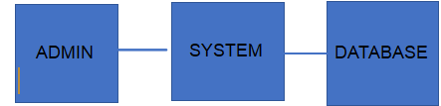

Entity Relationship Diagram (ERD)

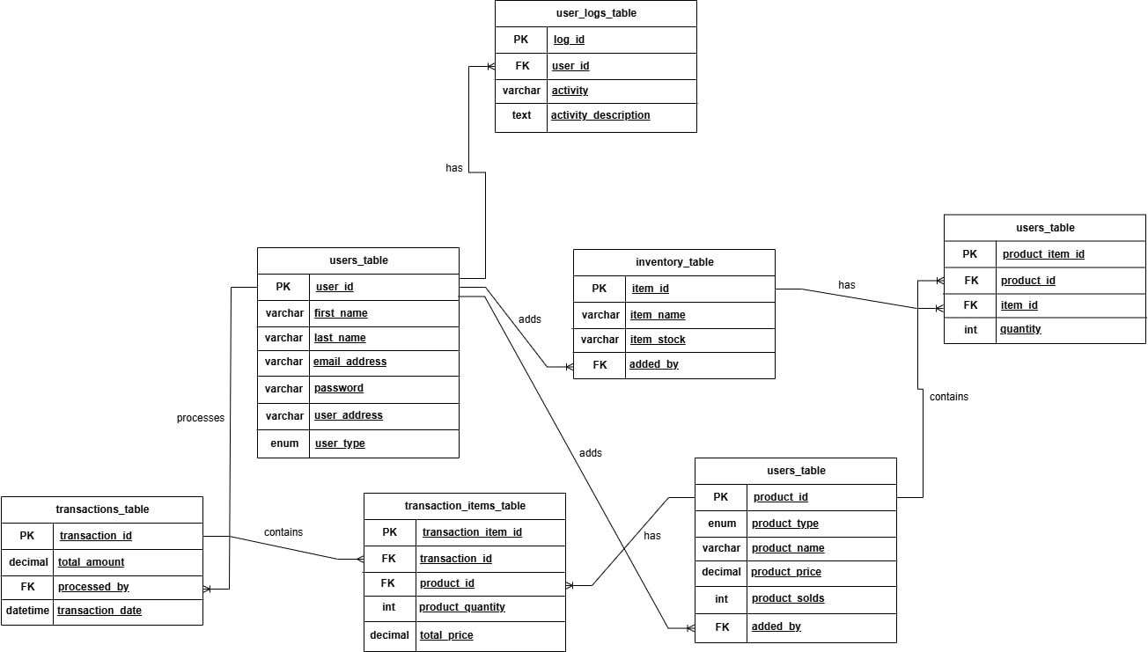
Entity Attributes
- user_id (Primary Key)
- first_name
- last_name
- email_address
- password
- user_address
- user_type (Admin / Staff)
- log_id (Primary Key)
- user_id (Foreign Key → Users.user_id)
- activity
- activity_description
- item_id (Primary Key)
- item_name
- item_stock
- added_by (Foreign Key → Users.user_id)
- product_id (Primary Key)
- product_type
- product_name
- product_price
- product_solds
- added_by (Foreign Key → Users.user_id)
- product_id (Foreign Key → Products.product_id)
- item_id (Foreign Key → Inventory.item_id)
- quantity
- transaction_id (Primary Key)
- total_amount
- processed_by (Foreign Key → Users.user_id)
- transaction_date
- transaction_item_id (Primary Key)
- transaction_id (Foreign Key → Transactions.transaction_id)
- product_id (Foreign Key → Products.product_id)
- product_quantity
- total_price
Relationships:
- A User can register several Inventory Items, meaning one user may handle the input or management of multiple stock records.
- A User can create multiple Products, showing that products are maintained and managed by system users such as administrators or staff.
- A User can handle multiple Transactions, where each transaction represents a completed process or sale.
- A Product can be included in many Transaction Items, meaning it can be sold repeatedly in different transactions.
- A Product can be included in many Transaction Items, meaning it can be sold repeatedly in different transactions.
- A Transaction can include multiple Transaction Items, where each item represents a specific product involved in that transaction.
- Each Transaction is managed by one User, identifying the person responsible for processing it.

End of Proposal

Note to the instructors handling this subject

CHED BSIT ALIGNMENT STATEMENT
This capstone project complies with CHED BSIT standards by demonstrating competencies in application development, database management, systems analysis and design, and emerging technologies such as machine learning. The project follows outcomes-based education principles and integrates ethical considerations, user safety, and data privacy.

REFERENCES
Carrillo, J. E., Carrillo, M. A., & Paul, A. (2004). Inventory Management. Https://doi.org/10.1002/047148296x.tie0987. S, s., & jogish, d. D. (2023). A study on inventory management” Https://doi.org/10.55041/ijsrem26621

Shaikh, A. L. (2024). Review Paper: “A Study on Effective Inventory Management And Control. INTERANTIONAL JOURNAL OF SCIENTIFIC RESEARCH IN ENGINEERING AND MANAGEMENT, 08(04), 1–5. Https://doi.org/10.55041/ijsrem31123

P, D. N., T, M. A., A, M. V. P., & B, M. S. K. (2024). A STUDY ON INVENTORY MANAGEMENT SYSTEM IN MODERNIZED BUSINESS ENVIRONMENT. INTERANTIONAL JOURNAL OF SCIENTIFIC RESEARCH IN ENGINEERING AND MANAGEMENT, 08(12), 1–6. Https://doi.org/10.55041/ijsrem39681
Zhang, P., & Yuan, A. Q. (2014). A Study on CPFR Inventory Management Technology. Applied Mechanics and Materials, 599–601, 2079–2082. Https://doi.org/10.4028/www.scientific.net/amm.599-601.2079
A use of automated system by Smith and Anderson(2021)
A study of Just-In-Time (JIT) by Nakamura and Lee (2018)
Study emphasized by intelligent systems and technologies Johnson et al. (2020)
Study of application-based systems by Dela Cruz and Santos (2022)
Study of examined inventory management or SME’s Dela Cruz and Santos (2020)
Study of proper software Pressman (2019)

